Credit Union

Presentation Notes

1 March 12, 2007

Our Mission
.
To improve the quality of life in Prince Edward Island by providing a vehicle for donors to meet their charitable interests in perpetuity at a minimum cost and maximum convenience

Directors
Norman Carruthers, President
John Ives, Vice President
John Robinson, Past President
Bruce Lewis, Secretary
David Campbell, Treasurer
Heather MacDonald
Anne Nicholson
Joyce Gaudet
Margaret Ching
Myron MacKay
David Anderson

Office Administrator ~ Marla MacDonald

Advisors
Investment Managers: Phillips, Hager & North
Solicitors: James Travers, Stewart McKelvey Stirling Scales
Auditors: David Arsenault, ArsenaultBestCameronEllis
Marketing: The Sharpe Group
Brochures: Anne Patterson-Kearns

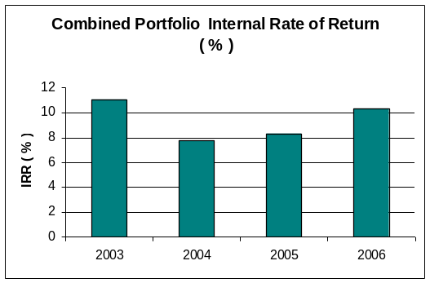

Charitable Numbers

Canada #: 890011190RR001
US IRS #: 30-0050801

Community Foundation of Prince Edward Island
Suite 105, Queen Square Place
Charlottetown, PEI C1A 4B3
Tel: 902-892-3440

 |  | 31-Dec-06
 | Community Foundation of PEI Consolidated Trust Fund Allocation and Valuation | PH&N 2006 Yr End FMV + Funds in Transit
 |  | $866,866.80
Fund # 1 |  | $10,835.20
Foundation Fund |  | $55,647.33
Community Fund |  | $61,804.22
Memorial Fund |  | $0.02
Phillips Scholarship Fund |  | $17,462.71
Carver Scholarship Fund |  | $125,234.38
Auld Fund |  | $11,414.21
Bonnell Scholarship Fund |  | $23,617.08
Glendenning Family Fund |  | $12,013.71
Taylor Memorial Fund |  | $13,586.02
Eric C Robinson Fund |  | $70,233.01
Summerside Natick |  | $12,300.10
Old Protestant Burial Ground |  | $54,310.38
P.E.I.Hospice Association |  | $101,628.84
Highfield Cemetery |  | $22,341.16
Founders Fund |  | $0.01
Visual Arts Fund |  | $3,698.86
Souris Fund |  | $17,061.87
C.Gorden Lord Scholarship Fund |  | $13,035.59
Architects Assn of PEI |  | $56,442.24
J. Melville Campbell Fund |  | $10,496.59
Agricultural Equipment Fund |  | $5,366.20
Dr Marlene Bryenton Fund |  | $9,165.89
David A MacKay Fund |  | $97,437.34
LM Montgomery Land Trust Fund |  | $551.72
Jessie Drummond Fund. |  | $2,152.44
Hesta MacDonald Legacy Fund |  | $1,074.04
Summer Islanders Legacy Fund |  | $5,979.10
Upson Fund |  | $1,033.37
Cumberland Rocky Point WI |  | $30,424.97
T Arthur Dawson Masonic Fund |  | $13,000.41
Living Memorial Trust |  | $7,517.80
Total FMValue of PH&N Portfolio |  | $866,866.80
Total Units held in the CTF
Current CTF Unit FMV
Adjusted Book Value (ABV) of CTF

